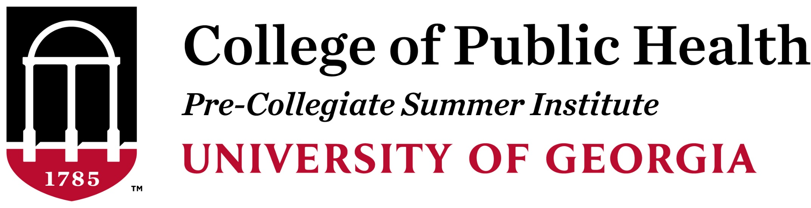
Pre-Collegiate Summer Institute Student Counselor
Dates: June 6-13, 2020 (+ additional training)
Hours per week: 25-30 Pay Rate: $500 program rate
Position Description
The Pre-Collegiate Summer Institute (PCSI) at the College of Public Health is seeking current undergraduate and graduate students interested in sharing their passion for UGA and Public Health with others and serving as mentors and counselors for high school students. This is a rewarding experience with many opportunities to develop life skills in leadership, communication, and mentorship.

Responsibilities
Counselors will work closely with high school students and assume responsibilities that underscore the important role of residence life and the educational experience of students. They will coordinate projects, activities and events while ultimately sharing their passion for UGA and its community. Evening and weekend work will be required.

Qualifications
Candidates must be current UGA undergraduate or graduate students in Public Health. Prior experience working with high school students is recommended, but not required. The candidate must have strong written and oral communication, organizational, and interpersonal and critical thinking skills.

Important Dates and Deadlines
Application Deadline: February 21, 2020. Early Submissions are strongly encouraged.
Applicant Interviews: Mid-March
Counselor Training: Training commitments leading up to the start of the program.
Pre-Collegiate Summer Institute: June 6-13, 2020

Apply Here
About the Program
The CPH Pre-Collegiate Summer Institute (PCSI) is an immersive, collaborative, and transformative one-week residential experience for high-achieving high-school students from diverse and underrepresented backgrounds. This program helps prepare college-bound rising seniors for success by giving them an exciting glimpse of college-level academics and residential life at the University of Georgia.

