HELLO, OLDER ADULTS!

As we stay home to prevent the spread of COVID-19, it’s just as important to stay engaged and stay connected. In fact, our health depends on it!

Here is a list of FREE ACTIVITIES to DO AT HOME on THE INTERNET. These activities can nurture your body, your mind, and your soul.

Times are tough right now. But you are not alone. We are all in this together!

You can also visit our website at www.EngagementActivities.com.

1: Exercise with the YMCA
ymca360.org/on-demand#/

2: Give or Receive a Friendly Phone Call
aarpmutualaid.zendesk.com/hc/en-us/requests/new

3: Start a Gratitude Journal
greatergood.berkeley.edu/article/item/tips_for_keeping_a_gratitude_journal

4: Test Drive a Classic Car
myclassiccar.com/video/

5: Create a Self-Care Plan
socialwork.buffalo.edu/resources/self-care-starter-kit.html

6: Learn a New Subject
thecrashcourse.com/courses

7: Play with the Dogs
explore.org/livecams/old-friends-senior-dog-sanctuary/senior-dog- gathering-room

8: Volunteer for the United Nations
onlinevolunteering.org/en

9: Try a Zumba Class
youtu.be/WYdJHpQL8-k?t=1

10: Compile Your Family Recipes
delishably.com/cooking-equipment/How-To-Write-Original-Food-Recipes- 10-Tips-for-Making-Your-Recipes-Easy-To-Follow

11: Relax Your Mind and Body
youtube.com/channel/UCjQxrBbp-9aCBzWIsiuHmiA

12: Rock Out with Legendary Bands
youtube.com/user/musicvault/featured

13: Teach Your Dog New Tricks
youtube.com/channel/UCgB9VgeE-JTe7dJPN9Q5n_w

14: Visit the National Parks
youtube.com/user/NationalParkService/videos

15: Write a Letter (Using Prompts)
blog.paperblanks.com/2018/02/28-new-journalling-prompts-for-letter-writing- month/

16: Enjoy a Concert at Lincoln Center
chambermusicsociety.org/watch-and-listen/playlists/the-joy-of-music/

17: Laugh to Saturday Night Live Episodes
nbc.com/saturday-night-live/explore/season-1

18: Transcribe Historical Documents
https://transcription.si.edu/instructions

19: Create a Memory Box
wikihow.com/Make-a-Memory-Box

20: See a Show at the Kennedy Center
youtube.com/user/TheKennedyCenter/videos

21: Re-Live Classic Sports Moments
youtube.com/playlist?list=PLJxnedevSwLq5E0iyQeRhltfpcdUAvhm0

22: Paint Mandala Stones (with Q-Tips!)
youtube.com/watch?v=dWxyUqfWYfs

23: View Historic Photos and Prints
loc.gov/pictures/

24: Listen to Poetry Readings
poetryoutloud.org/competing/listen-to-poems/

25: Take a Cooking Lesson
youtube.com/channel/UCl0kP-Cfe-GGic7Ilnk-u_Q

26: Reminisce, Reflect, and Write
static01.nyt.com/images/blogs/learning/pdf/2014/500PromptsNarrativ eAndPersonalWriting.pdf

27: Flex Your Brain Muscle with Games
verywellmind.com/top-websites-and-games-for-brain-exercise-2224140

28: Take a World Tour
360cities.net/

29: Hear Powerful New Ideas
ted.com/talks

30: Explore This Day in History
onthisday.com/

Here are some free communication and social media tools that are available online or with a Smartphone. Learn more by clicking here.
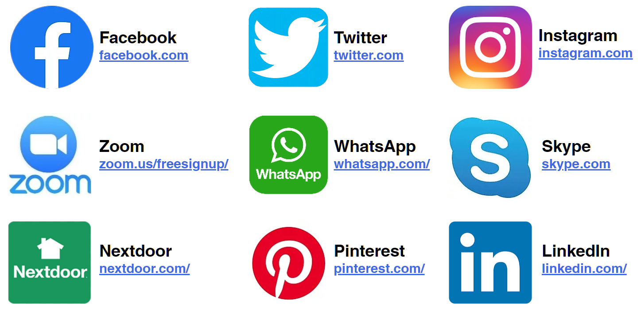

We recognize that not everyone has access to the internet. We also know that older adults are an extremely diverse population, so these activities may not be useful or appropriate for some individuals. At the same time, adults of all ages might enjoy these activities, too. Please stay tuned . . . .additional resources are coming soon!

About the Project / Contact

Hello! My name is Kim Wolf and I created this project in March 2020 for a COVID-19 Hackathon at the University of Georgia College of Public Health and the Institute of Gerontology.

I am pursuing a Master of Public Health in Gerontology, a Master of Social Work, and a graduate certificate in Interdisciplinary Qualitative Studies at the University of Georgia. I came to graduate school with nearly two decades’ of experience working with older adults and caregivers.

I believe that by working together, we can achieve health equity, end ageism, and ensure social justice for all. You can reach me at Kimberly.Wolf@uga.edu.

