How to Update Your Email Signature with the New Brand Logo and Tagline

First, if you haven’t formatted your email signature before, this is a good place to start:
https://brand.uga.edu/email-signature-builder/

This guide will show you where to copy and paste your new signature, or add the College’s new logo with tagline (as seen above).

Step 1: Download the CPH logo with our tagline, found at the bottom of this page: https://publichealth.uga.edu/news-events/visual-identity-logos-and-templates/

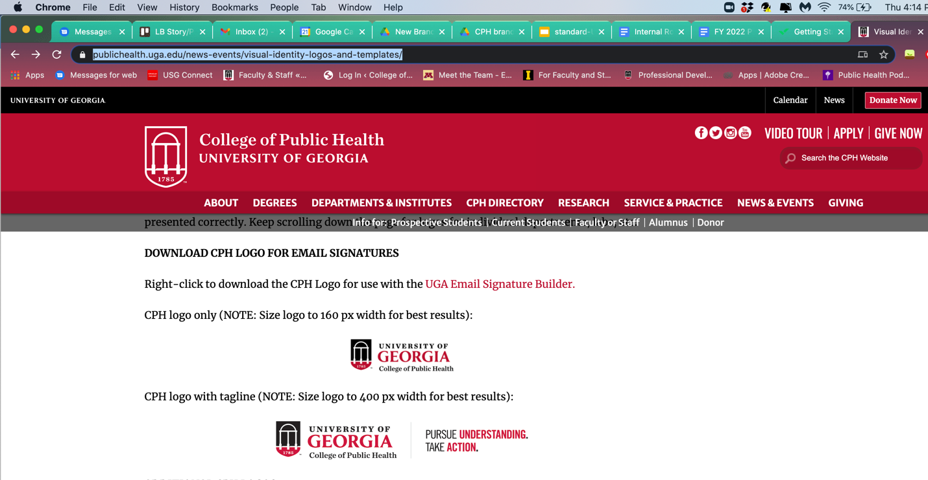

Step 2: Open Outlook, either in your web browser or desktop app.

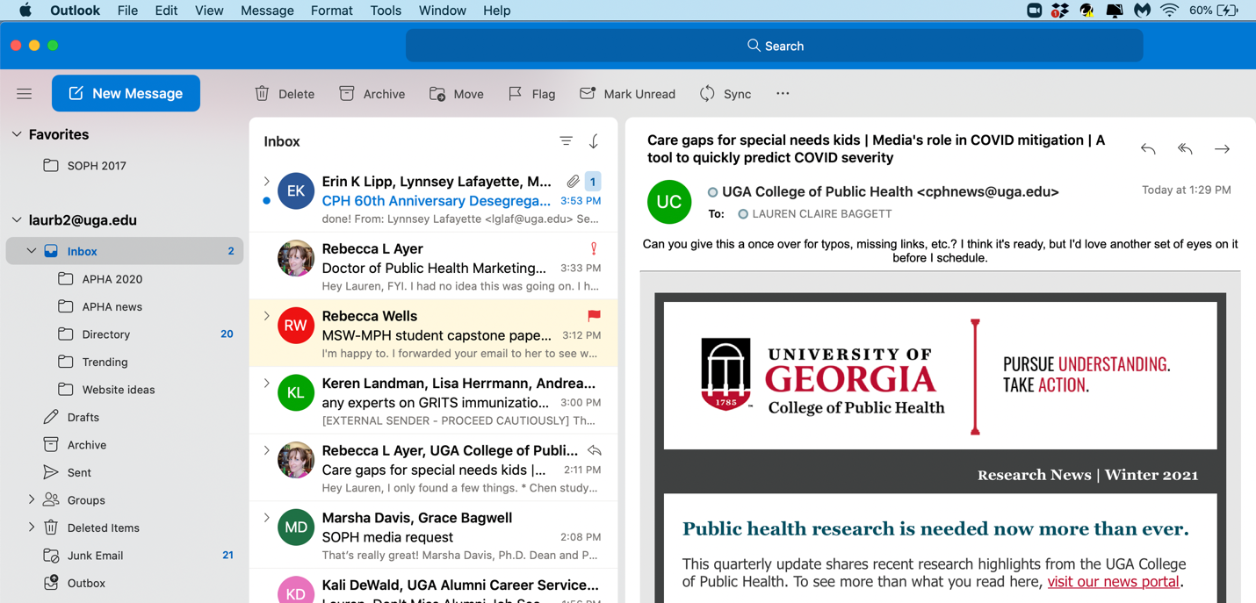

Step 3: Under Outlook, find and select Preferences.

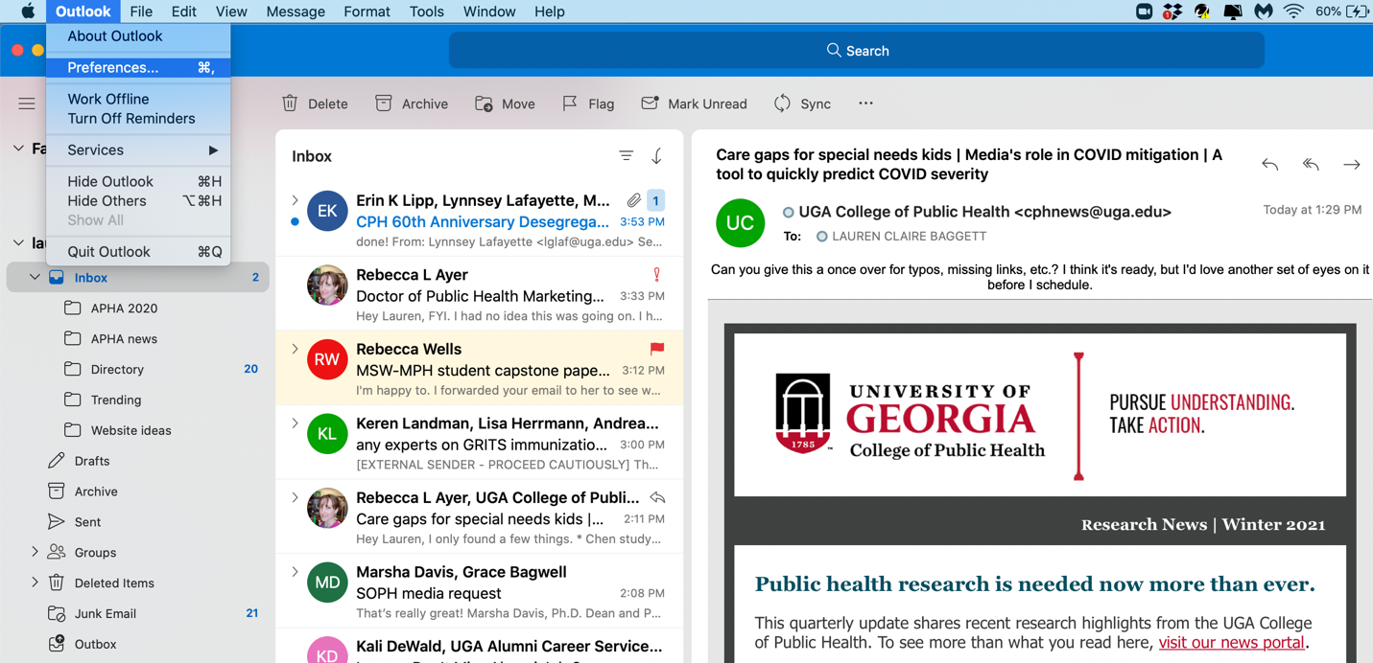

Step 4: On the second row of the Preferences table, find and click on Signatures.

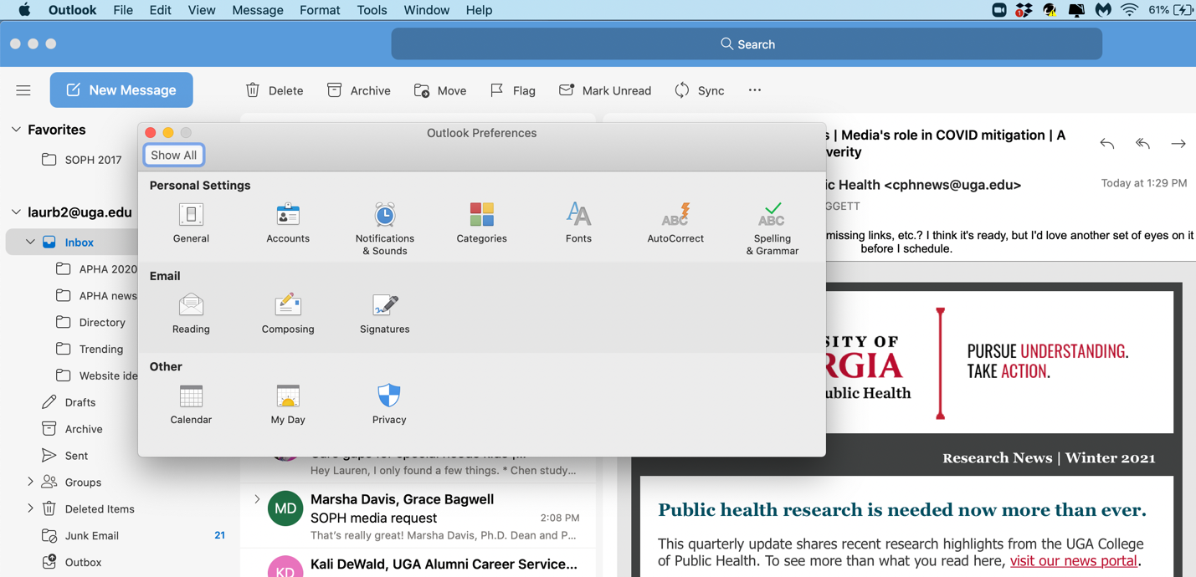

Step 5: Choose your primary email signature and select “Edit.”

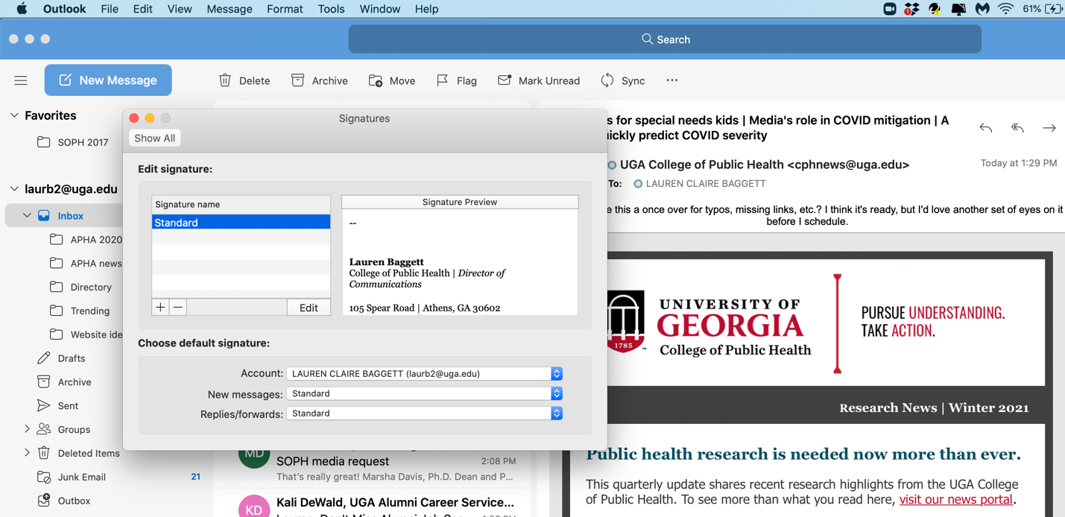

Step 6: If applicable, first paste your newly created brand signature. Select the UGA logo in your signature and hit delete. Your cursor should be blinking where the logo was placed.

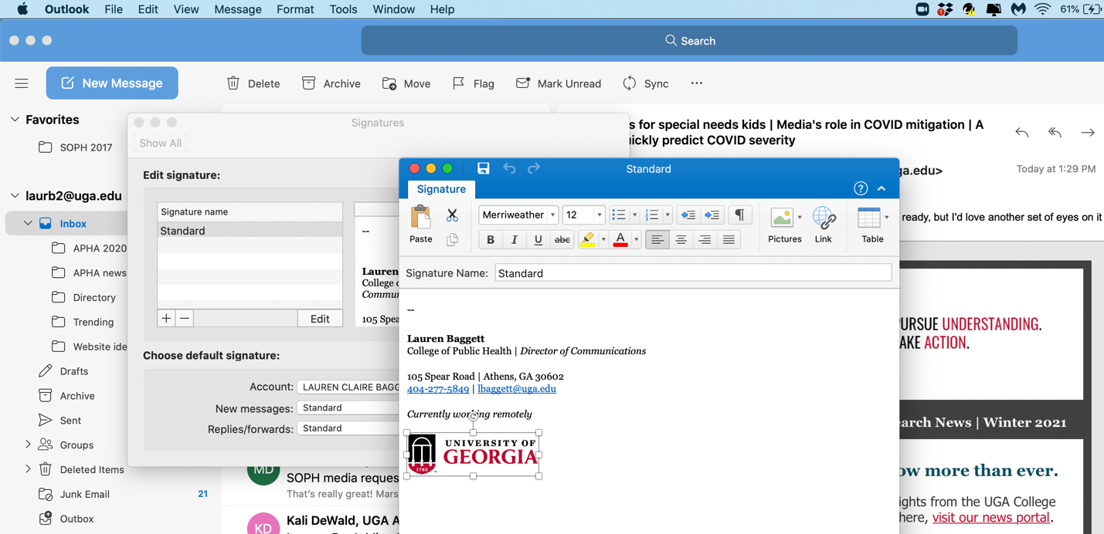

Step 7: Now, select Pictures from the header menu, and choose a photo from a file.

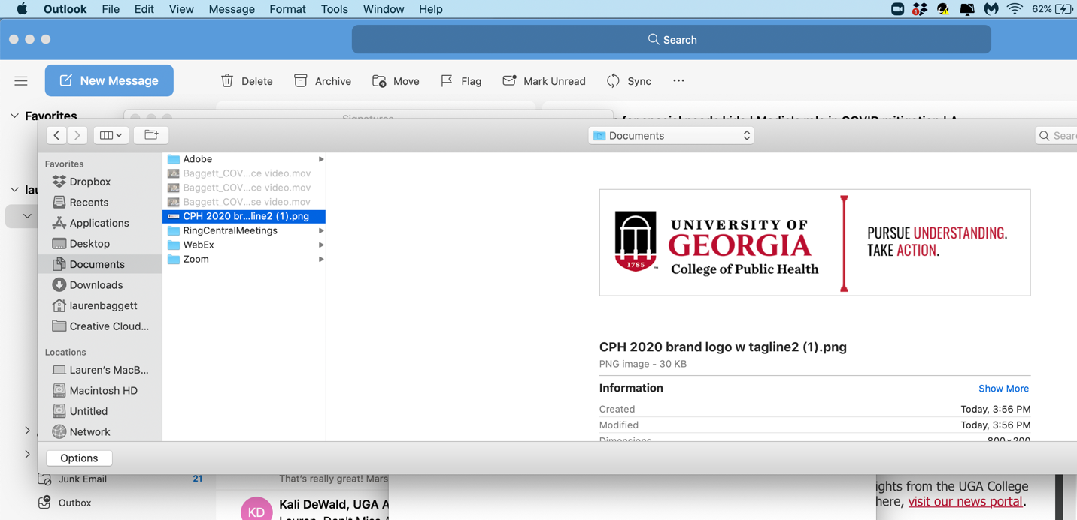

Step 8: Select the CPH logo with tagline from your files. The logo should insert where you deleted the UGA logo, below your contact information.

Step 9: Resize the image file to 400px wide.

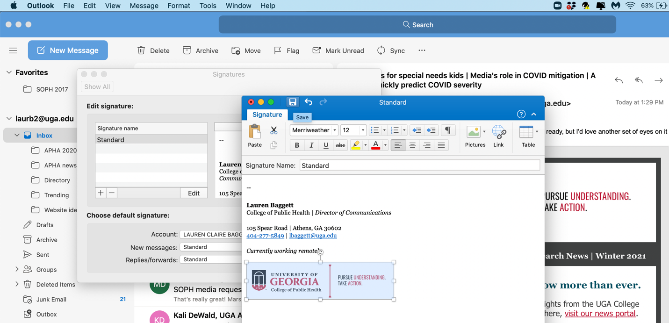

Step 10: Select the “Save” icon at the top of the blue box.

You’re done!

