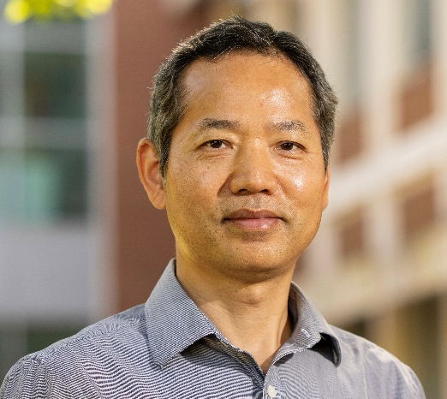

Optimizing Probiotic Delivery: Microencapsulation Strategies
for Enhanced Survival in the Human GI Tract

Fanbin Kong, PhD
Professor, Department of Food Science and Technology, College of Agricultural and Environmental Sciences, University of Georgia
Friday, February 28th, 2025
12:40pm-1:30pm
Location: Miller Plant Science Building, Room 1501
Dr. Fanbin Kong is a professor in the Department of Food Science and Technology at UGA. He earned his bachelor’s degree in Civil Engineering from Tianjin University in 1991 and a master’s degree in Environmental Engineering from Tsinghua University in 1998. After gaining seven years of industry experience, he pursued his Ph.D. in Food Engineering at Washington State University, completing it in 2007, followed by postdoctoral research at the University of California, Davis. Since joining UGA in 2011, Dr. Kong’s research has focused on designing human gastrointestinal models, studying the digestion of food and non-food materials, and developing innovative food processing technologies. He has published over 120 peer-reviewed scientific papers. At UGA, Dr. Kong teaches the undergraduate course "Fundamentals of Food Engineering" and a First-Year Odyssey (FYO) seminar on "Chinese Tea Culture," as well as the graduate-level course "Advanced Food Processes.

Seminar Series (EHSC 8030) | Spring 2025

